**Issue:** Un-Complete Order in USRP

**Resolution:**

Below are the steps to un-complete the order in QSOTS.

1. Search activity_id in acty_by_so view in Arthur.

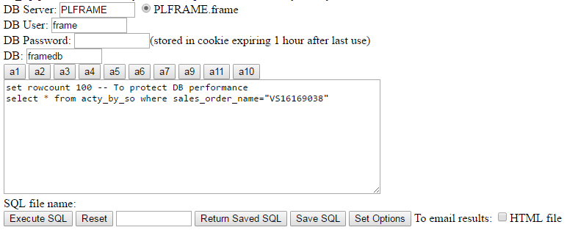

1. Query activity table with this activity_id.

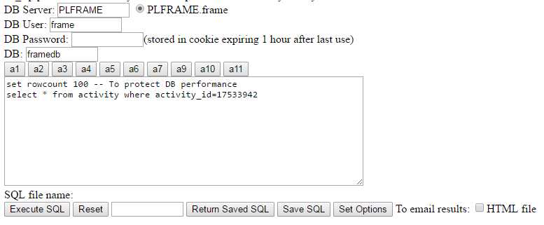

1. Update the activity table. Below is the update query:

UPDATE activity SET activity_status = 0,bill_status = NULL,biller_load_date_time = NULL,turn_up_load_type = NULL,turn_up_completion_date_time = NULL,biller_reject_reason = NULL,internal_fallout_reason = NULL WHERE activity_id in (xxxxxxxx)